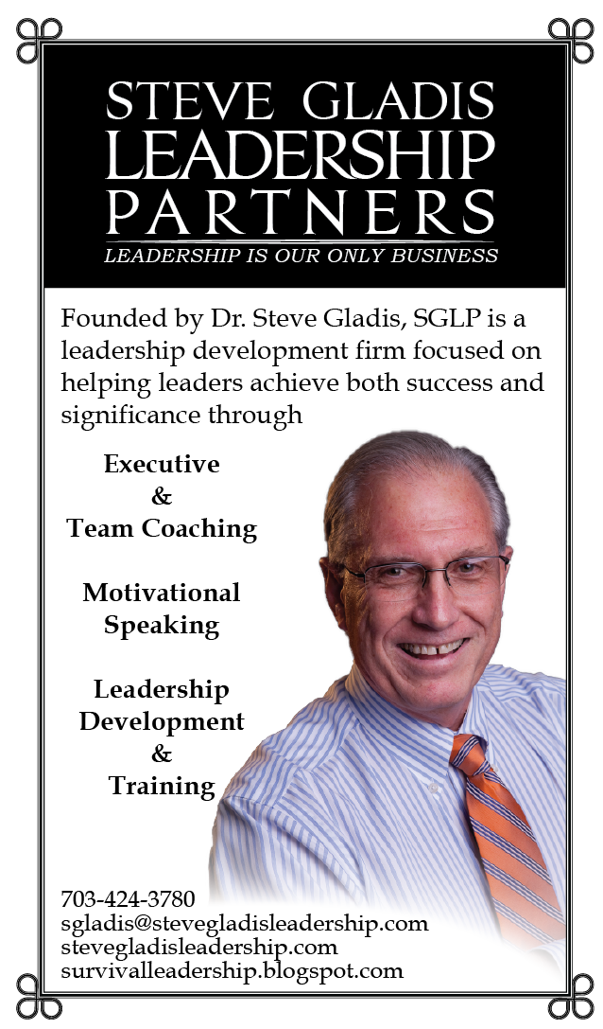

**[www.stevegladiscommunications.com](http://www.stevegladiscommunications.com)**

[**http://survivalleadership.blogspot.com**](http://survivalleadership.blogspot.com)

**In his newest book, *Positive Leadership: The Game Changer at Work*, Dr. Steve Gladis delves into the science behind what makes leaders positive and how that impacts those around them.**

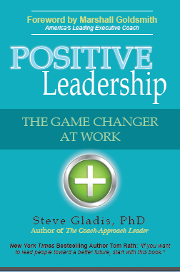

We all know intuitively that it’s more fun and more productive to work for a positive leader. But now we know just how much it means: A LOT. Happy employees produce 30% more, but only 20% of employees are happily engaged!

Positive leaders retain talent longer, get great engagement, and create climates of trust, safety, and innovation. Negative leaders do the opposite.



For a limited time, Dr. Gladis is offering a one-hour keynote presentation for a reduced rate to organizations that also purchase copies of *Positive Leadership* as follows:

50-99 copies @ $2,500

100+ copies @ $1,500

**SGLP OFFERINGS**

**SPEAKING ENGAGEMENTS**

* Company Meetings
* Dinner Keynotes
* Leadership Retreats

**TRAINING**

* Customized Workshop Sessions tailored to meet the specific needs of your organization

**EXECUTIVE COACHING**

* C-Level Individual and Executive Team Sessions

In his book, Dr. Gladis explores the impact of positivity in leadership by combining the research-based principles with a story to make the content memorable and meaningful. His simple recommendations can be implemented immediately to help you positively change your game!

***What People Are Saying About* Positive Leadership**

* *“… If you lead one person or 1,000, you’ll want to read this book [Positive Leadership] as quickly as you can and pass it on to someone you care about.”*

***Foreword by Marshall Goldsmith, the world’s most influential leadership thinker***

* *“If you want to lead people toward a better future, start with this book.”*

***New York Times Bestselling Author Tom Rath***

* *"Steve Gladis has done a spectacular job of combining the science of positive affect with a story that brings that science to life. Positive Leadership is a smart and sensible game plan for game changers of every kind.”*

***Daniel Pink, author of To Sell is Human, Drive, and A Whole New Mind***

* *“Positive Leadership is a must-read for anyone who wants to positively impact the culture, and ultimately the success, of an organization.”*

***Tony Bingham, CEO of ASTD***



**George Mason Enterprise Center**  
4031 University Drive Suite 200  
Fairfax, VA 22030

703-584-5504 (o)

703-424-3780 (c)

**CONTACT**

**sgladis@stevegladis.com**

**Follow Dr. Gladis on his website and leadership blog @**

[www.stevegladisleadership.com](http://www.stevegladisleadership.com)

<http://survivalleadership.blogspot.com>